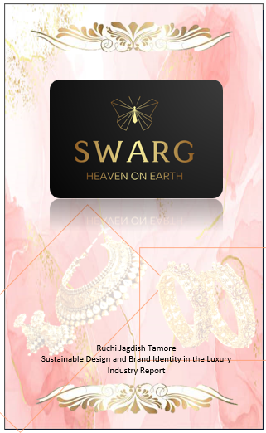

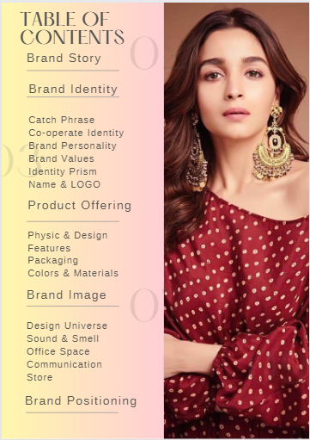**Brand Story**

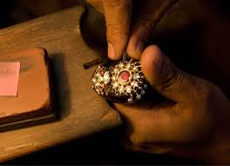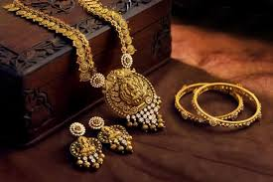

Swarg is a luxury jewellery brand that embodies the essence of Indian culture with a modern twist. It is a reflection of the vision and dedication of its founder, Aarti, who grew up in a small village in India surrounded by the beauty of nature and the colourful traditions of her culture. Aarti was always fascinated by the intricate and exquisite jewellery that the women in her community made by hand, using techniques that had been passed down for generations. As she grew older, she developed a deep appreciation for the artistry and craftsmanship of jewellery-making and realized the importance of preserving this cultural heritage.

However, Aarti also recognized the harsh reality of exploitation and unsustainable practices that often accompany the fashion industry. She was determined to create a brand that would showcase the beauty of Indian craftsmanship while upholding ethical and sustainable practices. Thus, Swarg was born out of this vision, and it has grown to become a symbol of quality, artistry, and integrity. Swarg's founder had a unique vision that was born out of her deep appreciation for the artistry and tradition of Indian jewellery-making, and her desire to bridge the gap between the old and the new. She recognized that the younger generation was becoming disconnected from their rich cultural heritage, and traditional jewellery pieces were no longer being worn or appreciated in the modern world.

Swarg's flagship store, located in the heart of Mumbai, is a testament to Aarti's vision and the brand's commitment to quality and sustainability. The store's design reflects the beauty and elegance of Indian culture, with rich colours, intricate patterns, and a warm and welcoming atmosphere. Every piece of jewellery sold at Swarg is handmade by skilled artisans using ethically sourced materials, ensuring that each piece is a work of art that tells a story.

The brand's success is a testament to Aarti's dedication and commitment to her craft. She faced many challenges along the way, from finding funding for her business to navigating the complex world of jewellery design and production. But through her persistence, passion, and unwavering vision, she was able to build Swarg into the successful brand it is today.

Swarg's commitment to ethical and sustainable practices, as well as its exquisite and timeless designs, have made it a beloved brand among those who appreciate quality, tradition, and elegance. The brand caters to the sophisticated and independent woman who seeks to express her unique style through exquisite jewellery that embodies tradition, artistry, and quality.

**Brand identity**

**Catch Phrase**

**Recreate the luxurious flavor of gold**

Recreating the luxurious flavor of gold while giving essence to Indian old jewellery in the modern world is our brand's unique proposition. We strive to bring the heritage and beauty of traditional Indian jewellery into the modern era by infusing it with contemporary styles and designs. Our products reflect the rich cultural heritage of India while being wearable in today's world. We take great pride in our ability to blend the best of both worlds, creating pieces that are both timeless and modern, bringing joy to our customers who appreciate the beauty of Indian jewellery.

**Co-operate identity**

Swarg's brand message is centered around women’s empowerment and independence, while also appealing to men who want to buy jewellery for their mothers, wives, friends, or daughters. The brand's pieces are designed to embody the essence of Indian old jewellery in a modern world, allowing women to wear traditional pieces in a contemporary setting. Swarg celebrates women's strength, beauty, and individuality, and is committed to creating pieces that empower and inspire its customers.

Swarg is committed to giving back to the community and promoting social and environmental sustainability. The brand supports local artisans and communities by using ethical and sustainable materials and production processes. Additionally, a portion of the brand's profits goes towards supporting programs that empower women and promote gender equality. Swarg is proud to work towards the UN's Sustainable Development Goals, including 5. Gender Equality, 8. Decent Work and Economic Growth, and 12. Responsible Consumption and Production.

**Brand personality**

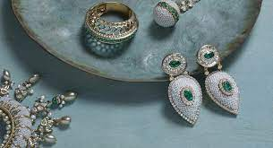 

Swarg is a high-end jewellery brand that embodies the essence of Indian craftsmanship and aesthetics. With a feminine and luxurious personality, Swarg is dedicated to empowering independent working women to express their individuality and style through exquisite and timeless jewellery pieces that embody tradition, artistry and quality. Swarg values ethical and sustainable practices and is committed to promoting responsible consumption and production. As a brand, Swarg inspires confidence, independence and self-expression in women while offering men a thoughtful and meaningful way to celebrate the important women in their lives.

**Brand Values**

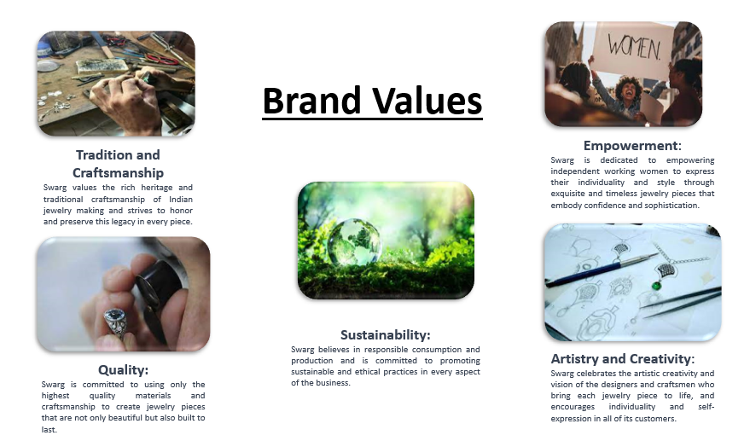

**Identity Prism**

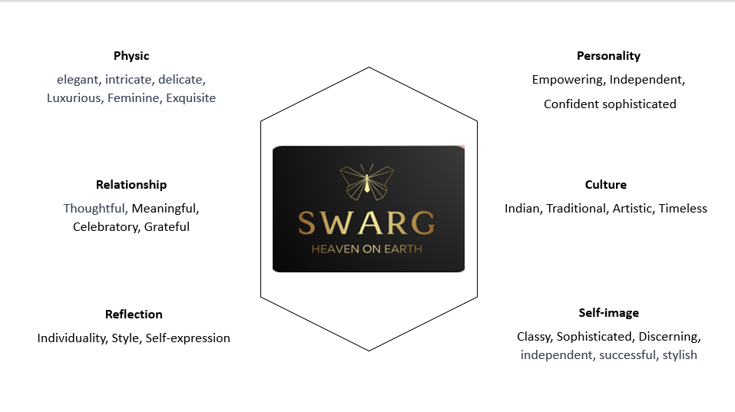

**Name & Logo**

The name "Swarg" comes from the Sanskrit word "Svarga" which means "heaven" or "paradise". It represents the idea of a perfect and blissful place where everything is beautiful and divine. In many ancient scriptures, heaven is described as a place of abundance, luxury, and splendour where everything is made of gold and precious gems.

By using the name "Swarg" for the jewellery brand, it evokes a sense of luxury, beauty, and exclusivity that is associated with the concept of heaven. The brand aims to offer its customers a heavenly experience through its exquisite and timeless jewellery pieces that are crafted with the highest level of artistry and quality. The name also reflects the brand's commitment to ethical and sustainable practices, as it strives to create a heaven on earth by promoting responsible consumption and production.

The Swarg logo is of a butterfly, an element that represents femininity and elegance. The butterfly symbolizes transformation, growth, and beauty, and also adds a touch of glamour and sophistication. The element creates a unique and memorable logo that captures the essence of the Swarg brand.

 

**Product offerings**

**Physic and Design**

The brand's collections are inspired by the rich cultural heritage of India, with each collection representing a unique aspect of the country's diverse and vibrant culture. The collections are designed to appeal to sophisticated and independent women who seek to express their unique style through jewellery that embodies tradition, artistry, and quality.

Swarg offers a range of membership programs for its most loyal customers, including bronze, silver, and gold tiers. Members receive exclusive access to limited-edition collections, personalized styling services, and invitations to private events. As a special thank you for their loyalty, Swarg offers personalized products for members on their birthdays, such as one-of-a-kind pieces featuring their birthstone or customized with their initials.

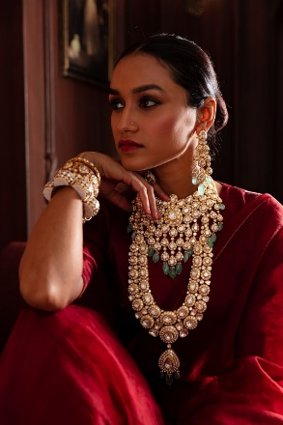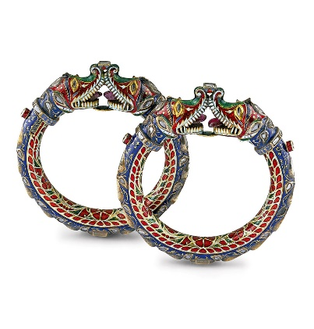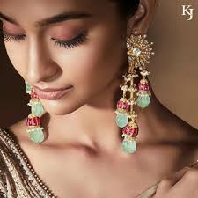

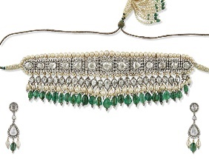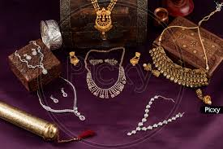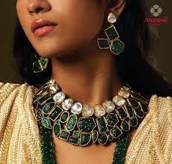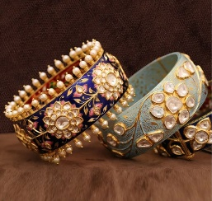

********

**Features**

Our jewellery designs draw inspiration from the beauty of the natural world, and each piece is crafted with meticulous attention to detail that ensures a perfect fit and a flawless finish. From delicate gold diamond necklaces to bold statement rings, every piece in our collection is a celebration of luxury, elegance, and timeless beauty.

**Packaging**

Swarg's packaging design is a reflection of the brand's commitment to delivering a luxurious and unforgettable experience to its customers. Each Swarg product comes in a sleek and elegant box with a rose gold finish, embellished with the brand's iconic logo. The box is made of high-quality, sustainable materials and is designed to protect the jewellery during transit while showcasing its beauty.

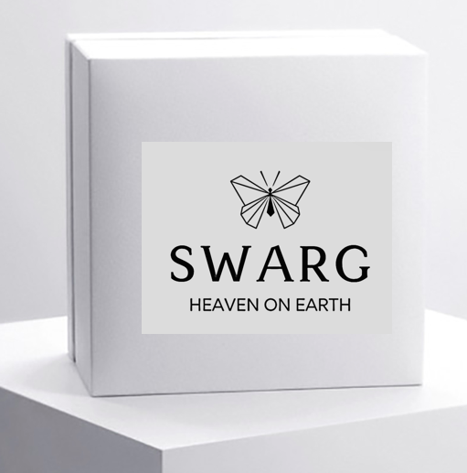 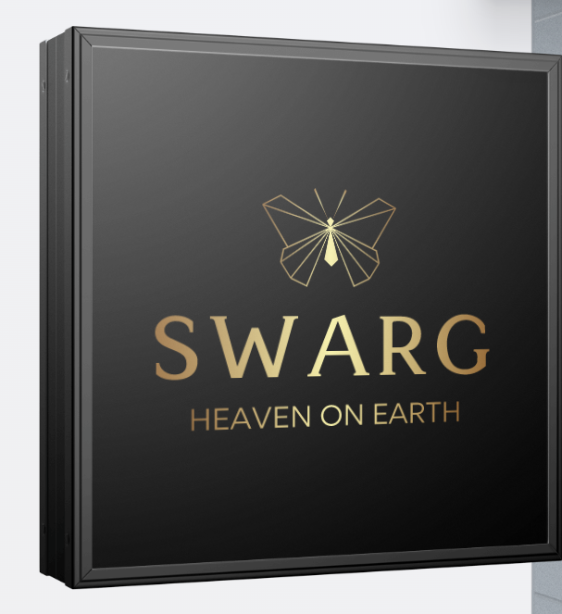

Each piece of jewellery is carefully wrapped in a custom-designed gift bag with the brand's logo and tagline printed on it. The gift bags come in a soft rose gold colour, consistent with the brand's overall aesthetic. The bags are not only visually appealing but also provide a convenient and stylish way for customers to carry and store their jewellery pieces. Inside the gift bag, the jewellery is wrapped in delicate tissue paper, adding an extra layer of protection and creating a luxurious unboxing experience for customers.

In addition to the gift bag and tissue paper, Swarg includes a thank you card in every package. The card is made of sustainable materials and features a message of gratitude for the customer's purchase. This personal touch demonstrates the brand's commitment to building a relationship with its customers and creating a positive shopping experience. In addition to the box, Swarg also offers a range of bespoke packaging options for special occasions such as weddings, anniversaries, and birthdays. These custom-made packages are designed to make the recipient feel truly special and reflect the occasion's significance. Swarg's packaging design ensures that each product is delivered in a memorable and meaningful way, making the entire purchase experience a reflection of the brand's commitment to delivering unparalleled quality and luxury.

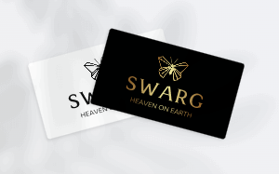 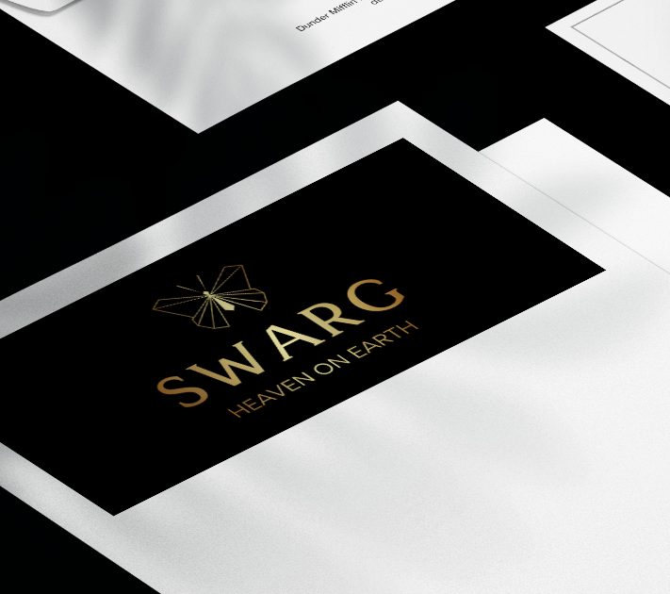 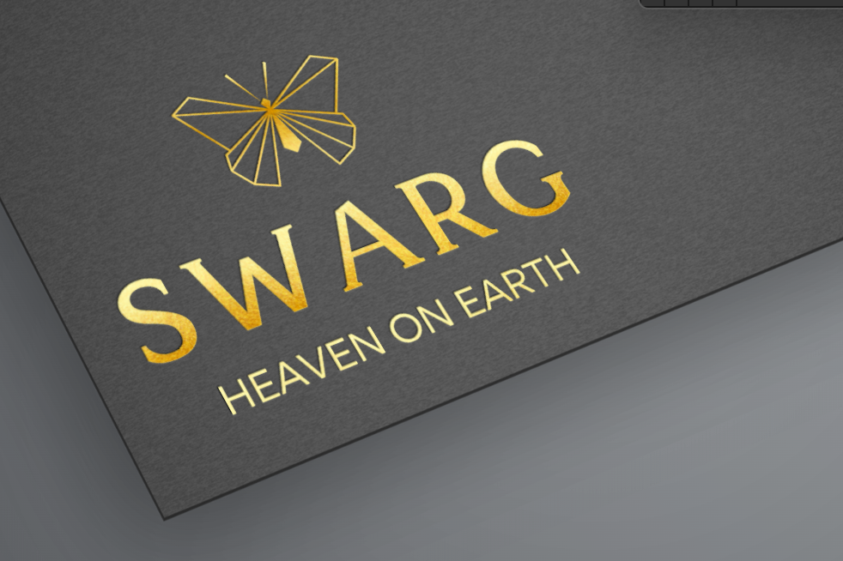

**Colours**

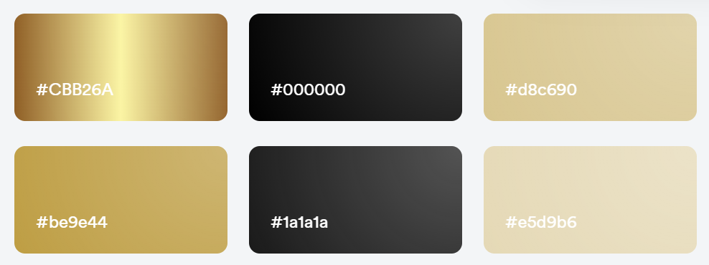

**Brand image**

**Design Universe**

Swarg is a luxury jewellery company that captures the beauty and elegance of Indian culture while adding a contemporary touch. Each piece of jewellery is painstakingly made by talented craftsmen utilizing ethically sourced materials, resulting in a work of art that tells a story. Because of the brand's dedication to ethical and ecological processes, as well as its elegant and timeless designs, it has become a favourite among people who value quality, tradition, and elegance. Swarg's flagship shop in the heart of Mumbai exemplifies the brand's commitment to quality and sustainability, with a design that represents the beauty and diversity of Indian culture**.**

**Sound & smell**

The sound of Swarg is that of gentle and melodious Indian classical music, evoking a sense of calmness and tranquillity. It is reminiscent of the rhythmic patterns of traditional Indian instruments like the sitar, the tabla, and the sarod. The music represents the essence of Indian culture and its timeless beauty, just like the brand's exquisite jewellery pieces. It invites customers to immerse themselves in the rich heritage of Indian craftsmanship and aesthetics while experiencing the luxury and elegance of Swarg.

The scent of Swarg is a subtle and delicate blend of floral and spice notes, inspired by the fragrances of Indian flowers and spices like jasmine, rose, and cardamom. It creates a warm and inviting atmosphere, transporting customers to the vibrant and colourful streets of India. The aroma is a representation of the brand's commitment to sensory experiences and its attention to detail, just like its meticulously crafted jewellery pieces. It creates a memorable and unique experience for customers, leaving them with a lasting impression of the beauty and grace of Swarg.

**Communication**

The brand's communication strategy is centered around showcasing the beauty and craftsmanship of its pieces. Through visually stunning campaigns and social media posts, Swarg invites its audience to indulge in the exquisite world of high-end jewellery. The brand's messaging is clear and concise, emphasizing the quality and exclusivity of its products.

Swarg's target audience is sophisticated and discerning individuals who appreciate fine jewellery and are willing to invest in pieces that will last a lifetime. The brand's communication strategy speaks directly to this audience, using language and visuals that resonate with their values and aspirations.

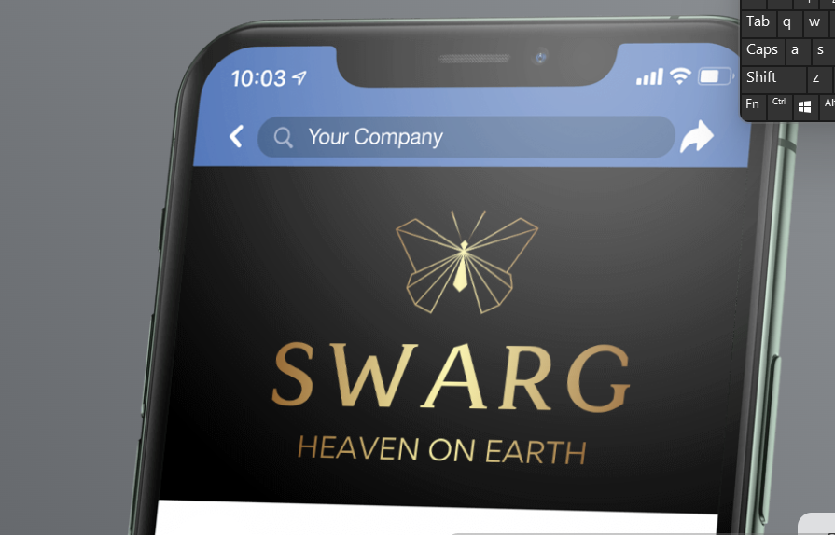 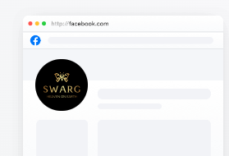 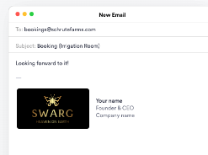 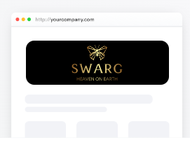

Phone App Social Media Newsletter Website

**Store**

Swarg outlets are meant to provide clients with a pleasant and beautiful shopping experience. The interiors are designed with high-quality materials such as polished marble, warm woods, and gentle lighting, which provide a feeling of refinement and luxury. The store layout is meticulously constructed to present the jewellery pieces in a visually attractive and utilitarian manner. The displays are intended to draw attention to the exquisite intricacies of each piece, allowing consumers to appreciate the skill and creativity that goes into each item.

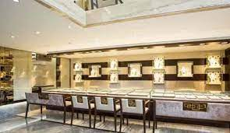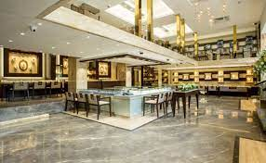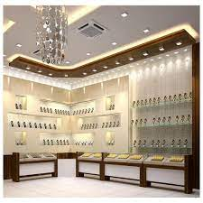

Swarg shops also provide comfortable seating spaces where clients may rest and peruse the selections at their leisure, in addition to the displays. The sitting rooms are also perfect for talks with brand specialists who can give advice.

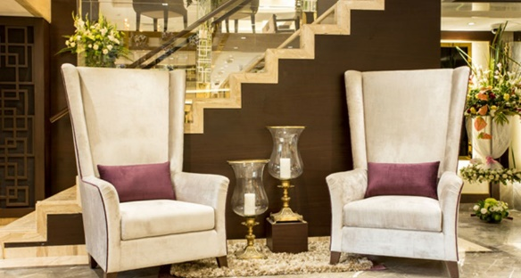 

Swarg boutiques may be found in some of the world's most prestigious shopping locations, such as Mumbai, New Delhi, Bangalore, New York, London, Paris, and Tokyo. The firm has chosen these places with care to guarantee that its products are available to discriminating clients who value the finer things in life. Swarg's characteristic jewellery items, such as necklaces, earrings, bracelets, and rings, are available at each store. Furthermore, for special occasions, customized packaging choices are available, adding a touch of elegance to the purchasing experience. Swarg's dedication to ethical and sustainable operations extends to its retail locations, which employ environmentally friendly products and procedures whenever feasible.

**Brand Positioning**

