Versace

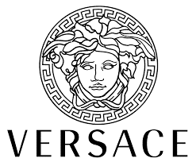

“Decide what you are, and what you want to express by the way you dress and the way you live”

-Gianni Versace

**Background**

Gianni Versace, more often known as Versace, is an Italian luxury fashion house established by Gianni Versace in 1978 and is well-known for its bold designs and vibrant colors. In his early childhood, Gianni Versace spent most of his time working for his mother, a local seamstress, and a businesswoman he became infatuated with fashion at this stage of his life and created his first masterpiece it was a blue one-shoulder evening gown. The modernized replica of this dress was worn by Princess Diana for almost after 40 years. Versace history started when the designer Gianni moved to Milan with his dream of becoming a fashion designer one day, as Milan was a hot new fashion hotspot for aspiring and experienced fashion designers of that era. He started his boutique in Milan’s villa de la spica, the hub for street shopping in Milan. His work was shown at one of the contemporary Art museums ‘Permanente’ and soon he began to attract love from the people due to his Invigorating and challenging Personality. In later years Versace became well-known in the industry Gianni wanted to make his imprint in the fashion world, so he began to modernize the sector by using a wide range of unconventional elements into his designs, including Swarovski crystals, leather, lace, and pins. his uncommonness sparked excitement in the fashion industry.

**About Versace**

Versace is a luxury brand with a premium, high-quality, and expensive positioning in the market. They feature a large selection of clothing for women, men, children, and the house, as well as home collections including linens, blankets, and cups.

The House of Versace is an established fashion powerhouse that continues to influence both trends and individuals, according to its vision statement, which reads: "To make women and men feel attractive and empowered."

Coming to the Versace logo, is the head of the Greek mythological figure Gorgon Medusa. Medusa was a stunning woman with beautiful hair, upon the curse of Minerva, her gorgeous hair was transformed into countless snakes and anyone who made eye contact with her was transformed into a stone statue. Gianni was a knowledgeable gentleman He wanted to create a certain fashion that will shock people and stop them from moving like a stone. Gianni intended to represent power, strength, and beauty in his brand image by using the metaphor of Medusa. Versace was able to become instantly identifiable because of the use of this sign, which conveys a high level of elegance, luxury, and a genuine sense of hand-crafted craftsmanship. Gianni's diverse ancestry, which includes being of Greek descent and having been born in the Italian city of Reggio Calabria near Greece, served as the inspiration for this logo. Since the logo specifies both the name and the image, it is a logotype. The Versace logo has seen numerous minor alterations over the course of its existence. The Versace Myth, which is the company's central tenet, combines a glamorous and seductive fashion universe.

The company creates, distributes, and sells luxury goods ranging from haute couture to prêt-a-porter lines, jewellery, and perfumes. Versace creates a lifestyle for their clients through their products. From its inception in 1978, they have adhered to the concept of luxury, and they offer its clients and customers a boundary-free, consistent, and attractive brand.

**Recognition**

Designer Gianni Versace is renowned for bringing an aesthetic touch to the fashion business. Well-known celebrities like Madonna, Princess Dianna, Elton John, Tina Turner, and most recently Michelle Obama wore Versace to the last state dinner. Versace rose to prominence as a leading fashion designer in the 1980s and 1990s. His first collection was developed in 1978, and his couture line, which was introduced to his other apparel lines in 1989, was born the following year. Gianni Versace was one of the most well-known fashion designers of the 20th century, creating upscale apparel, accessories, fragrances, cosmetics, and home goods. distributing clothing created from cutting-edge materials like plastic, metal, and leather. As Versace gained popularity, it began to face competition with Armani, as the saying went. The mistress is dressed in Versace while the wife is dressed in Armani. Donatella Versace, his younger sister, took over as creative director after the terrible passing of Versace in 1997 and immediately contributed a spark that no one else could have. with a genuine comprehension of Gianni Versace's methods, Donatella undoubtedly continued Versace's real legacy and reputation.

For the 42nd academic awards in 2000, Jennifer Lopez wore one of Donatella’s jungle dresses. JLo looked stunning in a silk chiffon dress with a jungle print, and everyone wanted to see photographs of her wearing it. People grew so fixated on it that it inspired Google to develop its image search feature. Donatella made care to draw attention to it when she unveiled her spring 2020 women's wear collection because it was the most popular search term at the time.

In addition to expanding as a designer in the fashion industry, Versace now operates more than 300 outlets worldwide. With only 12 in its place of origin, Italy, and an incredible 108 outlets in China.

**Strategies**

**Creating supermodels**

Versace created the supermodel by selecting a few models off the runway and elevating them to higher levels of elegance. Most models remained modest clothes horses, but this elite rose to the status of deities. Versace, who was already conjuring up images of classical gods with his elegantly draped gowns, fashioned the ideal women to wear them.

Donella Versace, who took over as designer soon after her brother's unexpected death, put on a huge tribute show that culminated with five of the original supermodels—Cindy Crawford, Naomi Campbell, Claudia Schiffer, Helena Christensen, and the former First Lady of France Carla Bruni taking to the runway together while Freedom by George Michael played in the background. Gianni Versace's most famous scene from 1991, when four supermodels walked arm in arm down the runway while George Michael sat in the front row, was recreated in the finale.

**Campaigns**

alongside his enthusiasm for design. Gianni had an excellent eye for marketing. To set his ads apart from the competition, he stressed the need to only hire supermodels and top photographers. He was afterward referred to as the "father of supermodels".

The new era campaign is aimed at enhancing the company's overall perception among younger consumers and giving them the chance to connect and identify with the brand as a whole rather than simply with a certain collection.

**Collaborations**

Versace is a worldwide brand with a strong commercial presence. Versace only operated in Italy until 1991. The requirements of buyers and their purchasing habits changed over time. Versace began working with young musicians like Dua lipa and Zayn malik as well as well-known companies that are popular among teenagers in order to expand its market. Versace had to look for new generations in order to succeed in the company.

To provide customers with an online shopping experience, Along with H&M in 2015, Versace launched another clothing and accessories collection that is available in H&M stores. Although the company doesn't need any media to advertise itself, Versace has given the matter a lot of attention. i.e., to establish themselves as a synonym for luxury. As the brand for superstars, Versace has been promoted directly or indirectly by these well-known persons throughout its history. In 2006, it established a partnership with Lamborghini and delivered a Lamborghini Murcielago LP640 VERSACE. Versace designed the interior of the car, including the seats, which are woven with the brand's insignia. Only 10 of the cars were delivered to maintain their exclusivity. In 2008, Versace and AgustaWestland worked together to create the AW109 Grand Versace VIP luxury helicopter

Donatella collaborated with certain micro-influencers to present one of her fall/winter collections. She specifically worked with 8 young people who, while being anonymous, made a significant contribution to the brand thanks to their entrepreneurial spirit.

**Celebrity endorsements**

Gianni saw the clout he could gain by dressing superstars such as Elton John, Princess Diana, Michael Jackson, Cher, and countless others, and suddenly everyone wanted to wear the same dress that Cher had worn or the same blouse that Elton John had worn. Versace's celebrity endorsements are dominated by Jennifer Lopez and Lady Gaga. Dua Lipa was named the brand's face in the fall/winter of 2021 which attracts gen z. Blake Lively recently donned a gorgeous, interchangeable, eye-catching Versace dress at the MET Gala, adding a taste for Versace's brand image in public. Celebrities frequently wear Versace attire for events, award ceremonies, and parties that draw customers.

**Retail Marketing**

The Versace Group, with a global revenue of more than one billion euros, sells its goods directly through a network of more than 200 owned boutiques and 1,500 wholesalers.

Versace recently redesigned its retail strategy by opening new stores, strengthening their multi-channel approach, and increasing investments in the effectiveness of crucial business planning processes. This was done in response to the evolving challenges of global sourcing and the change in consumer purchasing habits.

Capri Holdings, formerly Michael Kors Holdings, ran 149 full-price Versace retail locations across the globe, 803 wholesale doors, and 60 outlet stores as of April 2, 2022.

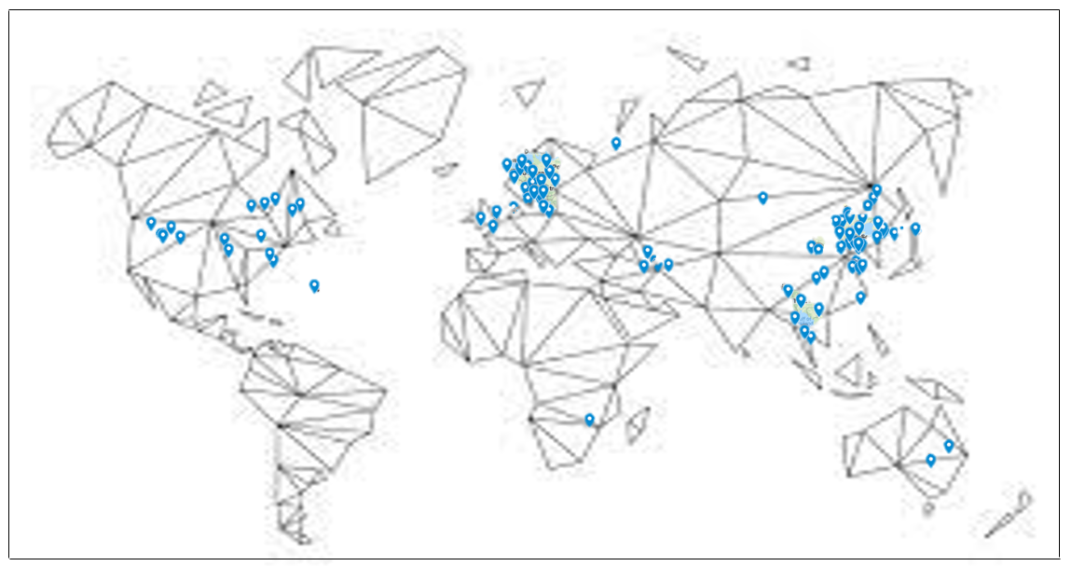

**Fig 1: showing retail stores of Versace around the world**

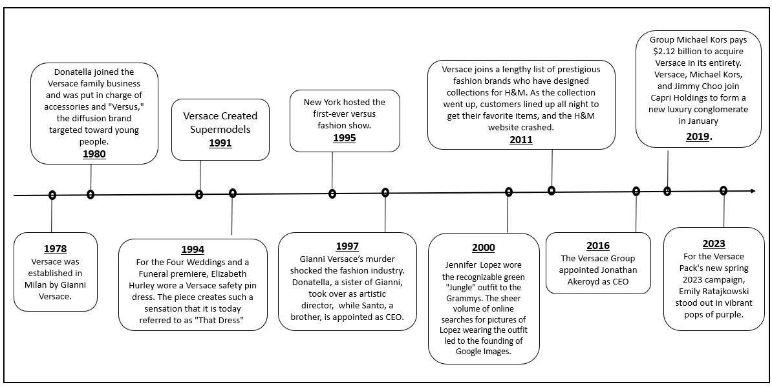

**Fig 2: Timeline of Versace’s Growth**

**Success**

Gianni Versace was among the most well-known fashion designers in the world at the time of his death in 1997. He built a global empire that elevated Italy to the top of the fashion world and established the country as the epitome of unparalleled luxury in less than twenty years.

Versace's grandiose masterpieces, spectacular theatrical costumes, and innovative menswear design helped him become well-known on a global scale.

Versace's global network of 130 boutiques was valued at $807 million at the time of his passing. Currently, the corporation is worth roughly $1.7 billion. Versace's value as a 50% stakeholder would be approximately $800 million.

Six times between 2016 and 2022, Brand Finance estimated the Versace brand's brand value. The Versace brand valuation has appeared in ten brand rankings, including the best and most valuable Luxury & Premium brands, the biggest brands in Europe, and the best brands from Italy.

**Problems faced**

* The COVID-19 pandemic had an effect on Versace, just like it did on many other high-end companies. The company's sales and revenue were impacted by the closing of physical storefronts and decreased consumer spending.
* The owner of the Versace and Michael Kors brands, Capri Holdings, anticipates having difficulty supplying the demand for expensive accessories for at least six months.
* Because of intense competition in the high-end luxury market, Versace's sales growth has stagnated.
* fashion businesses in New York seized roughly 3,000 fake goods, among them Hermes, Versace, Tory Burch, and Michael Kors.
* A t-shirt design that displayed a list of cities, including Hong Kong and Macau, as separate countries rather than parts of China brought unwelcome attention to Versace in 2018. Calls for a brand boycott in China were made as a result of the situation.

**Questions**

1. **Versace has faced criticism for not adhering to shifting consumer preferences and for not altering its brand image to appeal to younger generations. The brand has a reputation for being out of date and excessively centered on its recognizable Medusa logo. what fields of study should Versace pursue to draw young people's attention?**
2. Versace may better understand consumer preferences and shifting trends by conducting market research.
3. Versace can adapt its brand image and goods to appeal to a younger audience by obtaining information about the interests and needs of young people in terms of fashion.
4. Versace may concentrate on designing designs that are contemporary and new while keeping utilizing its recognizable Medusa mark. Working with upcoming designers and artists might help the brand incorporate fresh concepts.
5. Versace can build products and marketing campaigns that appeal to young people by understanding their cultural values and preferences. Versace's design decisions and marketing language may be influenced by research on the cultural trends and tastes of younger generations to better appeal to these groups.
6. Ecology and sustainability are issues that younger generations are becoming more concerned with. Versace can attract young individuals who value eco-friendly fashion by combining sustainable materials and methods into its designs.
7. Social media is an effective technique for interacting with younger demographics. Versace can spend money on social media marketing initiatives that target younger audiences and work with young people's favorite influencers and celebrities.
8. young people frequently adopt new technology first. Versace can investigate the use of cutting-edge technologies to develop immersive shopping experiences and interact with younger customers, such as augmented reality or virtual reality.
9. Versace can work with well-known streetwear companies that are well-liked by younger shoppers. This will help the company project a more modern image and appeal to a younger audience.
10. Versace might use music to project a younger image. The company can collaborate with musicians to design unique looks for them to wear in music videos and performances. This will enable the company to reach a larger audience and draw in younger clients who are passionate about both fashion and music.

Versace may, in general, better understand and relate to younger consumers by exploring these subjects of study, as well as develop a more relevant and alluring brand image.

1. **The largest luxury firm in the world, LVMH, is the owner of numerous fashion labels, including Marc Jacobs, Christian Dior, Louis Vuitton, and Fendi. In 2022, LVMH's overall revenue increased by 23%. The company Kering, which owns Gucci, Yves Saint Laurent, Balenciaga, Alexander McQueen, and Bottega Veneta, is another significant opponent. Revenue from Kering's luxury brands increased by an astounding 27% in the last year What strategy should Versace use to combat them in the specialized markets?**

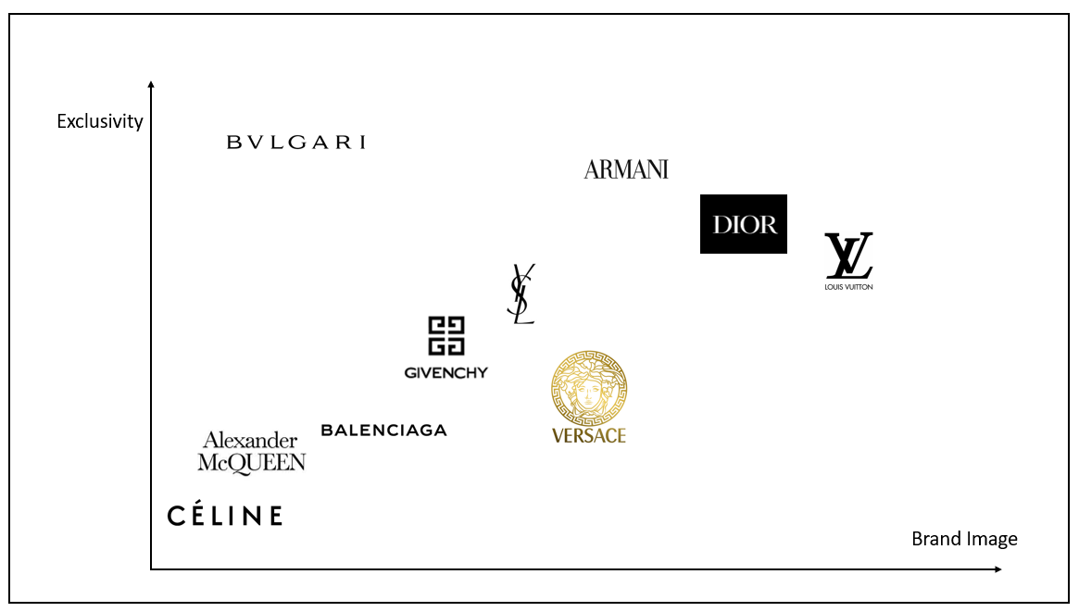

**Fig 3: The positioning of Versace in relation to luxury brands such as Kering and LVMH is depicted on the above map.**

**Versace may think about using the following tactics to compete with LVMH and Kering:**

1. **Increase product offerings:** Versace can increase the range of luxury products it offers in addition to its current emphasis on apparel and accessories. The company may, for instance, establish a line of home design goods or enter the beauty industry.
2. **Concentrate on digital innovation:** LVMH has made significant investments in this area, and Versace can compete by creating a solid digital strategy. Using technology to improve customer experience, investing in e-commerce platforms, and establishing a strong online presence through social media are a few examples of how to do this.
3. **International expansion:** Versace may concentrate on increasing its global presence to take on LVMH. This can entail expanding its footprint in current markets or entering new ones.
4. **Sustainability:** Kering and LVMH have prioritized sustainability, and Versace may compete by implementing more ecologically responsible procedures. This can entail utilizing environmentally friendly materials, decreasing waste in the supply chain, and enhancing transparency on the environmental impact of the brand.
5. **Concentrate on brand identity**: Versace can compete by concentrating on creating a distinctive and one-of-a-kind brand identity despite Kering's strong portfolio of premium brands. This can entail highlighting the brand's Italian background, utilizing premium components, and coming up with strong, standout designs.
6. **product innovation:** Versace can engage itself to produce one-of-a-kind, special goods that stand out in a crowded market.   This could involve establishing new product lines or working with designers or artists to develop limited-edition collections.
7. **Digital marketing:** Versace can compete by creating a solid digital strategy, as Kering has been investing considerably in this area. This can entail investing in e-commerce platforms, interacting with customers on social media, and utilizing technology to improve the customer experience.
8. **Shopping experience:** Versace may concentrate on giving customers a special and unforgettable in-store experience. This might entail designing distinctive shop environments, providing specialized services, and holdingexclusive events.
9. **For a long time, Versace has struggled with counterfeiting. The brand is a top target for counterfeiters who want to take advantage of its fame and make money from the sale of knockoff goods because of its recognizable designs and high-end luxury appeal. How can it address this given the existence of a global market as the main problems include economic loss, reputational harm to a brand, and Legal concerns about safety?**

Versace has taken several steps to prevent counterfeit culture, including a court case, a brand protection program, technology to stop counterfeiting educating consumers, the global alliance

**Versace can take the following additional measures to better combat counterfeiting:**

1. Versace can improve its partnerships with authorized retailers and distributors to ensure consumers buy genuine goods. Versace may also improve its relationships with authorized retailers and distributors.
2. Use blockchain technology to track and trace your items: You may use blockchain technology to track and trace your products from the factory to the consumer. More customer transparency can result from doing this, which can prevent counterfeit goods entry into the supply chain.
3. Versace may work more closely with organizations like the International Trademark Association and the Anti-Counterfeiting Group (ACG) to advance the industry (INTA). By doing so, it will be easier to collaborate, set industry-wide standards, and exchange best practices.

By performing these extra actions, Versace can increase its efforts to combat counterfeit goods, safeguard its reputation as a premium brand, and give customers more confidence that they are buying genuine Versace products.

**References**

1. [**https://youtu.be/HQZap3rCqJg**](https://youtu.be/HQZap3rCqJg)
2. [**https://youtu.be/ZEqUxO3bTt0**](https://youtu.be/ZEqUxO3bTt0)
3. [**https://youtu.be/AlYvJO62oyA**](https://youtu.be/AlYvJO62oyA)
4. [**https://youtu.be/WnQlT6P6Ao0**](https://youtu.be/WnQlT6P6Ao0)
5. [**https://en.wikipedia.org/wiki/Versace#:~:text=Gianni%20Versace%20S.r.l.%20**](https://en.wikipedia.org/wiki/Versace#:~:text=Gianni%20Versace%20S.r.l.%20)
6. [**https://graphiste.com/blog/success-story-histoire-logo-versace/**](https://graphiste.com/blog/success-story-histoire-logo-versace/)
7. [**https://logo.com/blog/the-backstory-and-history-behind-the-versace-logo#:~:text=%22Decide%20what%20you%20are%2C%20what,and%20the%20way%20you%20live.%22**](https://logo.com/blog/the-backstory-and-history-behind-the-versace-logo#:~:text=%22Decide%20what%20you%20are%2C%20what,and%20the%20way%20you%20live.%22)
8. [**https://www.mbaskool.com/brandguide/lifestyle-and-retail/2832-versace.html**](https://www.mbaskool.com/brandguide/lifestyle-and-retail/2832-versace.html)
9. [**https://thesocialgrabber.com/marketing-strategies-and-swot-analysis-of-gucci-and-versace/**](https://thesocialgrabber.com/marketing-strategies-and-swot-analysis-of-gucci-and-versace/)
10. [**https://www.yumpu.com/en/document/read/63489876/versace-marketing-report**](https://www.yumpu.com/en/document/read/63489876/versace-marketing-report)
11. [**https://gevrilgroup.com/versace/gianni-versace-medusa-logo/**](https://gevrilgroup.com/versace/gianni-versace-medusa-logo/)
12. [**http://www.hautehistory.co.uk/versace-timeline**](http://www.hautehistory.co.uk/versace-timeline)
13. [**http://www.vam.ac.uk/content/articles/g/gianni-versace/#:~:text=Versace%20became%20internationally%20renowned%20for,Linda%20Evangelista%20and%20Naomi%20Campbell**](http://www.vam.ac.uk/content/articles/g/gianni-versace/#:~:text=Versace%20became%20internationally%20renowned%20for,Linda%20Evangelista%20and%20Naomi%20Campbell)**.**
14. [**https://www.redliondata.com/versace-believe-in-individuality-and-the-freedom-to-be-whoever-you-want-to-be/**](https://www.redliondata.com/versace-believe-in-individuality-and-the-freedom-to-be-whoever-you-want-to-be/)
15. [**https://blucactus.blue/versaces-marketing-strategy/**](https://blucactus.blue/versaces-marketing-strategy/)
16. [**https://www.paragon-id.com/en/inspiration/luxury-products-and-counterfeiting-challenges-and-solutions**](https://www.paragon-id.com/en/inspiration/luxury-products-and-counterfeiting-challenges-and-solutions)
17. [**https://hbr.org/2019/05/how-luxury-brands-can-beat-counterfeiters**](https://hbr.org/2019/05/how-luxury-brands-can-beat-counterfeiters)
18. [**https://cavesocial.com/versace/**](https://cavesocial.com/versace/)
19. [**https://www.marketing91.com/marketing-mix-of-versace/**](https://www.marketing91.com/marketing-mix-of-versace/)
20. [**https://www.businesswire.com/news/home/20220929005400/en/Versace-Chooses-Board-to-Transform-Retail-Planning**](https://www.businesswire.com/news/home/20220929005400/en/Versace-Chooses-Board-to-Transform-Retail-Planning)
21. [**https://440industries.com/versace-vs-louis-vuitton-everything-you-need-to-know/?utm_content=cmp-true**](https://440industries.com/versace-vs-louis-vuitton-everything-you-need-to-know/?utm_content=cmp-true)
22. [**https://chicpursuit.com/louis-vuitton-vs-versace/**](https://chicpursuit.com/louis-vuitton-vs-versace/)
23. [**https://www.lopinion.fr/economie/michael-kors-is-overpaying-for-versace-glamour**](https://www.lopinion.fr/economie/michael-kors-is-overpaying-for-versace-glamour)
24. [**https://issuu.com/mollierobinson/docs/mollie_robinson_**](https://issuu.com/mollierobinson/docs/mollie_robinson_)
25. [**https://galeriejoseph.com/en/2022/02/02/how-do-luxury-brands-influence-young-people/**](https://galeriejoseph.com/en/2022/02/02/how-do-luxury-brands-influence-young-people/)
26. [**https://www.slideshare.net/AmeliaHoineithiem/versace-69824161**](https://www.slideshare.net/AmeliaHoineithiem/versace-69824161)
27. [**https://prezi.com/3noqllg7y39g/versace-presentation/**](https://prezi.com/3noqllg7y39g/versace-presentation/)
28. [**https://slideplayer.com/slide/14524059/**](https://slideplayer.com/slide/14524059/)